# Certificate Go-Lang Programming

## 1. Go-Lang Dasar

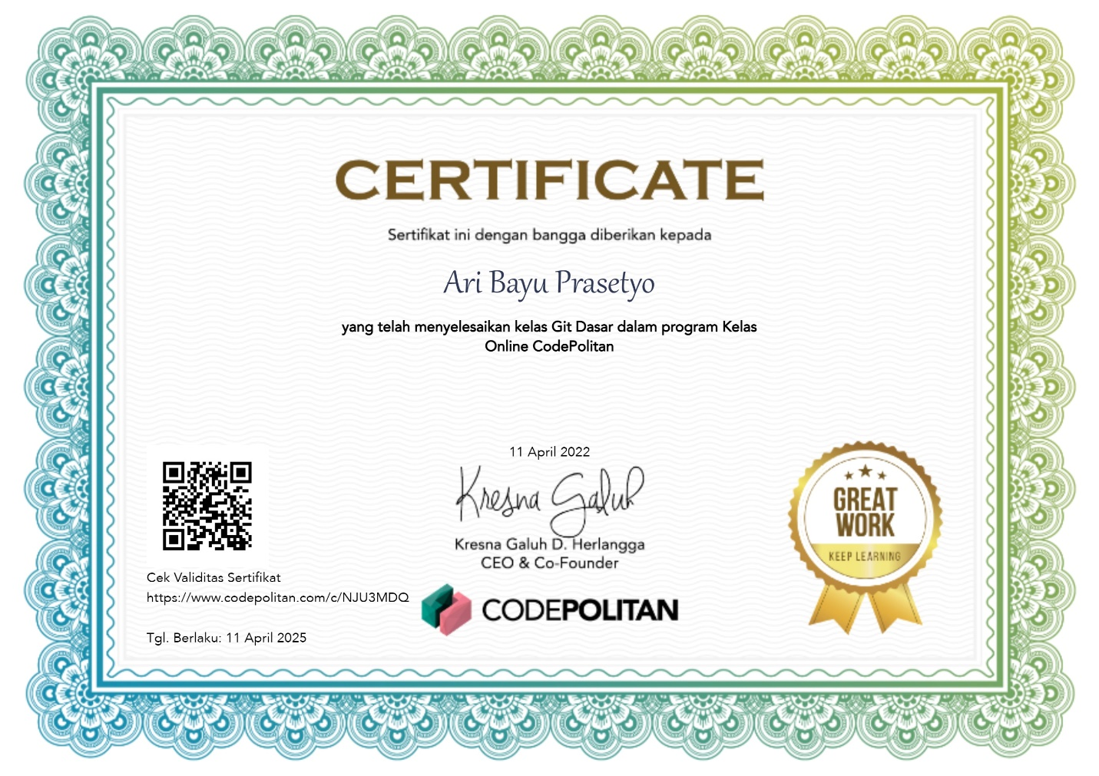

## 2. Go-Lang Modules

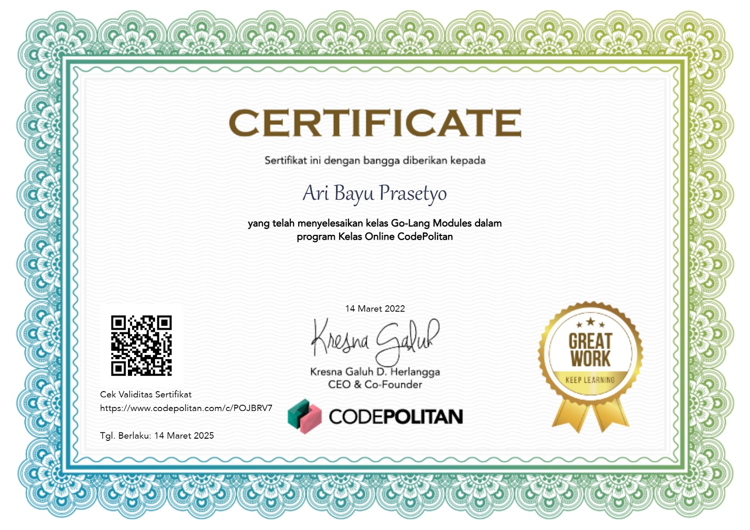

## 3. Go-Lang Unit Test

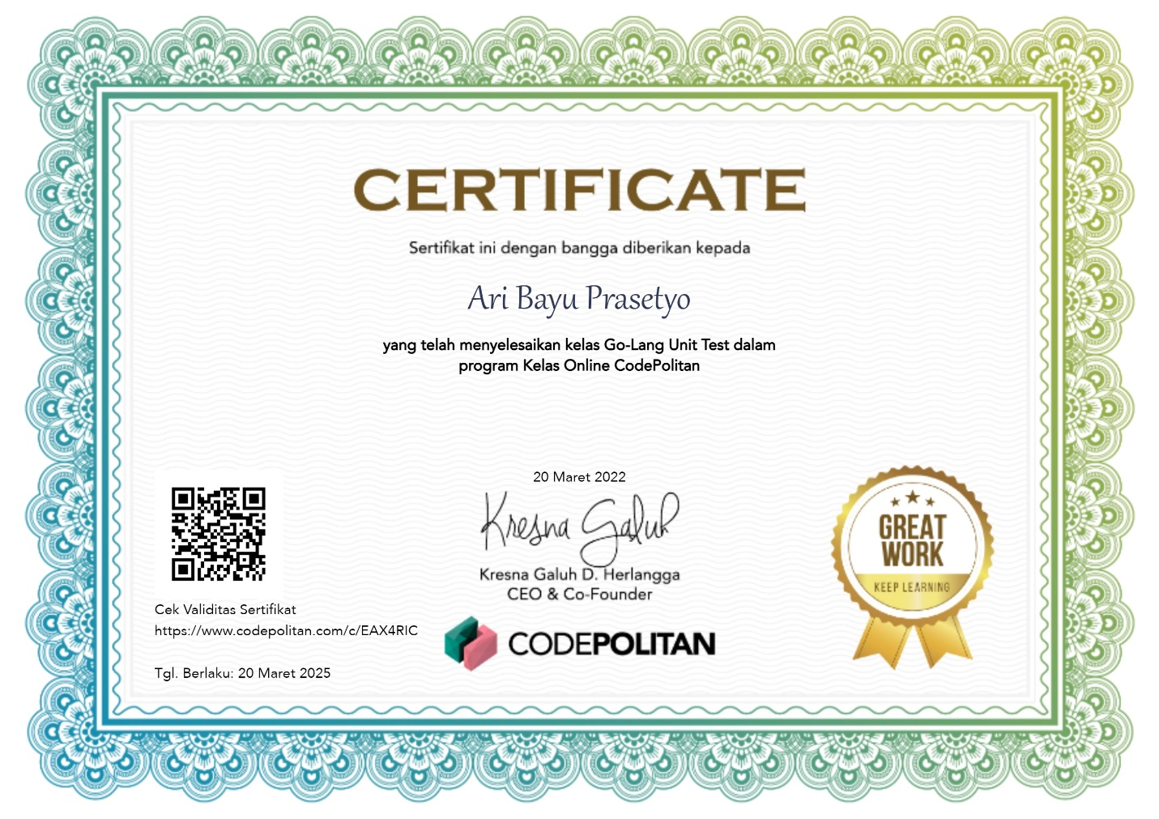

## 4. Go-Lang Goroutines

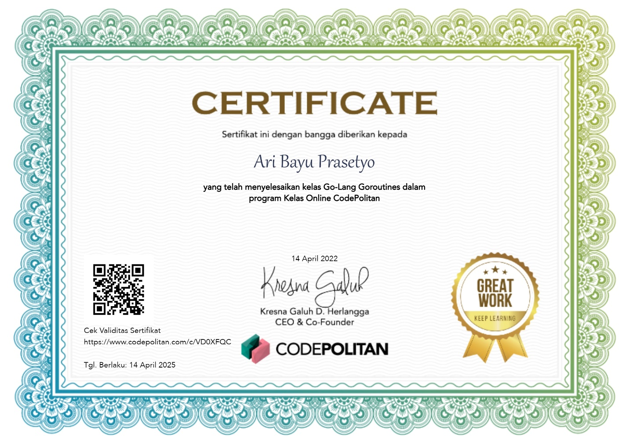

## 5. Go-Lang Context

